Computational Modelling with Python & Pygal

Lesson 1 | Lesson 2 | Lesson 3
Human Population Growth | Fish Population & Harvesting | Forestry Conservation
Exponential growth, loops, line chart | Logistic growth, Euler method, carrying capacity | Multi-variable functions, line & bar charts

Lesson 1: Human Population Growth
Learning Objectives
By the end of this lesson you will be able to: write a function that uses a loop to model exponential growth; use Pygal to create a line chart with multiple scenarios; explain why growth rate has a bigger long-term effect than starting population.

Background: What is Exponential Growth?
When a population grows by the same percentage each year, it is called exponential (or compound) growth. A small town growing at 5% per year will double roughly every 14 years. This is the same mathematics behind bank interest — the more you have, the more you gain.

Key Term: Growth Rate
A growth rate is expressed as a decimal. 5% growth = 0.05. Each year: new population = old population x (1 + growth_rate)

The Code
Read the function below carefully, then answer the questions.
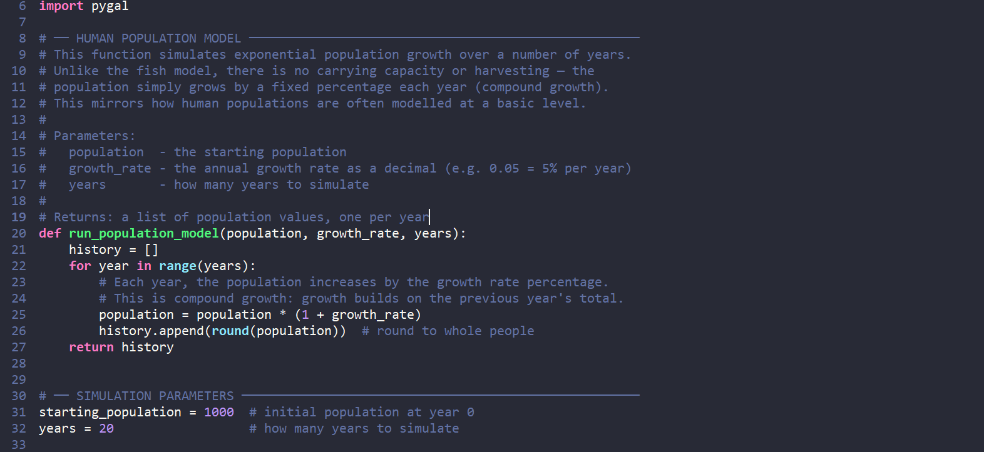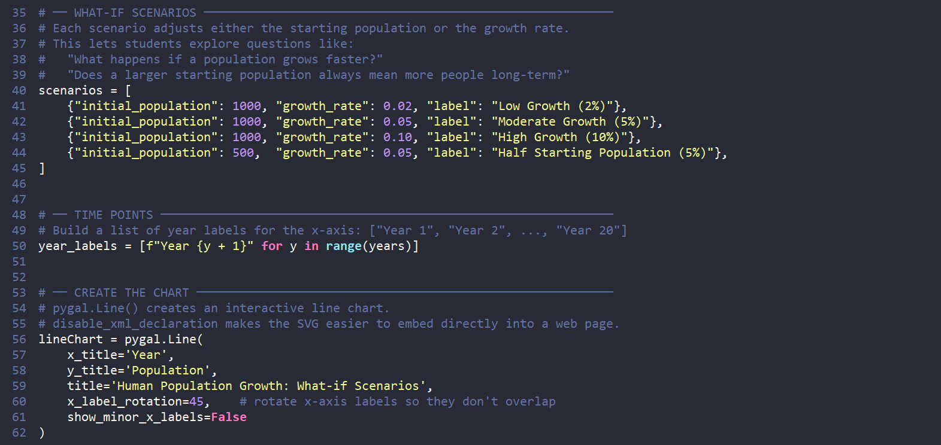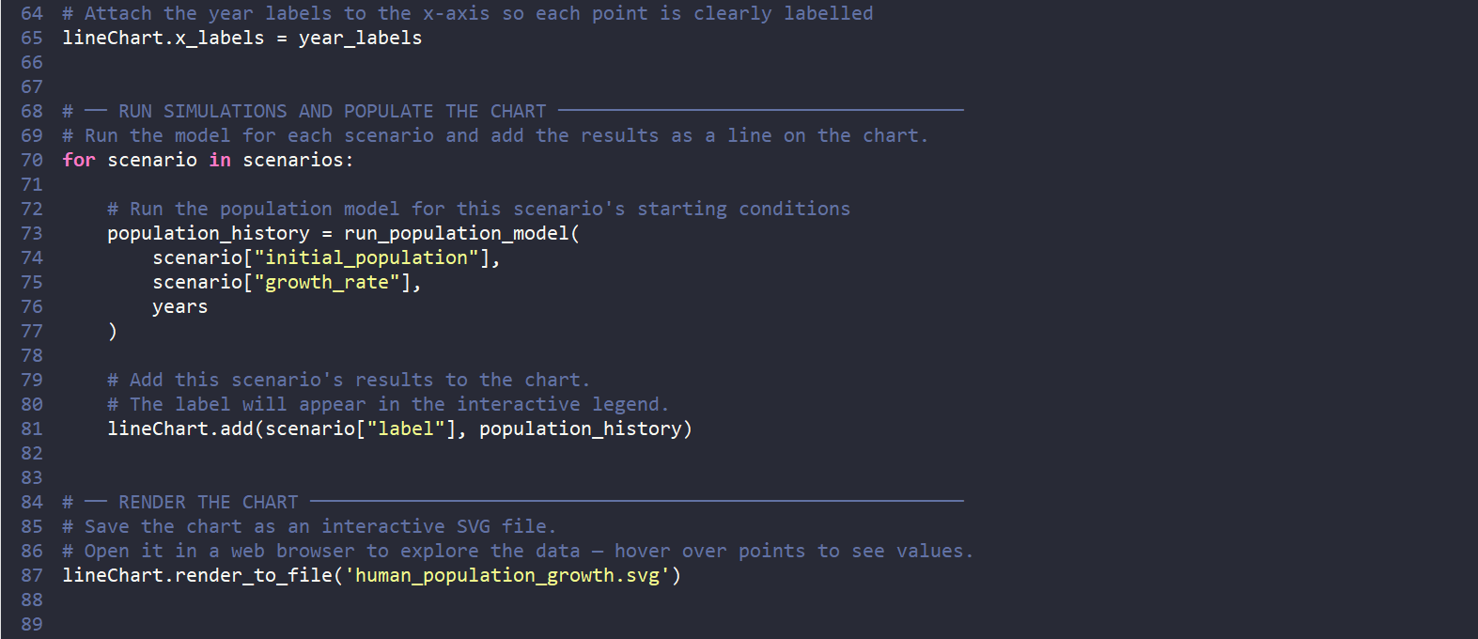

Check Your Understanding
Q1 — Reading the Code
- What does the variable history store?

Your answer:

- Why does the code use round(population) instead of just population?

Your answer:

- What does max(nextPop, 0) do in the fish model (Lesson 2)? Why might we need the same idea here?

Your answer:

Q2 — Predicting Outputs
Without running the code, predict: after 20 years, which scenario will have the highest population? Why?

Your prediction and reasoning:

Q3 — Surprising Result
Run the code. Look at the "Half Start, Same Rate" line compared to "Moderate Growth (5%)". What do you notice about how far apart they stay over time? What does this tell you about starting population versus growth rate?

Your observation:

Extension Tasks
- Add a fifth scenario with a negative growth rate (e.g. -0.02) to model a shrinking population. What does the chart look like?
- Real-world challenge: Look up the current population growth rate of two different countries. Add them as scenarios using a realistic starting population of 1,000,000.
- Can you add x_labels to the chart so each point shows the actual year (e.g. 2024, 2025...)?

Lesson 2: Fish Population & Sustainable Harvesting
Learning Objectives
By the end of this lesson you will be able to: explain the difference between exponential and logistic growth; identify what carrying capacity and harvest rate mean in a real-world context; interpret a Pygal line chart to draw conclusions about sustainability.

Background: Why Fish Populations Are Different
Unlike human populations in simple models, fish live in environments with limited food, space, and shelter. At some point the environment cannot support more fish — this limit is called the carrying capacity. On top of that, fishing removes fish from the population. If too many fish are caught, the population collapses.

Parameter | What it means | Example value
population | Current number of fish | 50
growthRate | How fast fish reproduce | 0.5
carryingCapacity | Maximum the environment supports | 100
harvestRate | Fish removed per time unit | 5 or 10

The Core Formula
The fish model uses a logistic growth equation. It looks complex, but each part has a meaning:
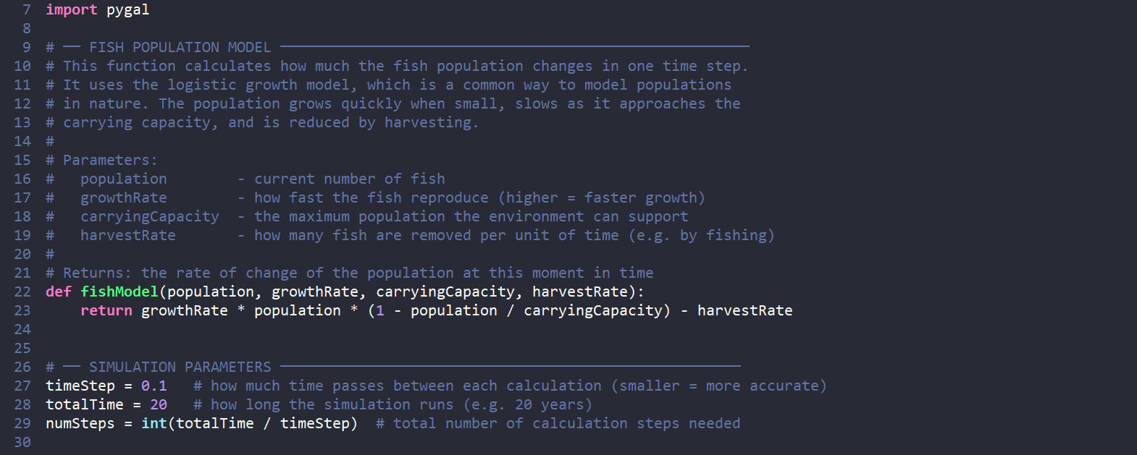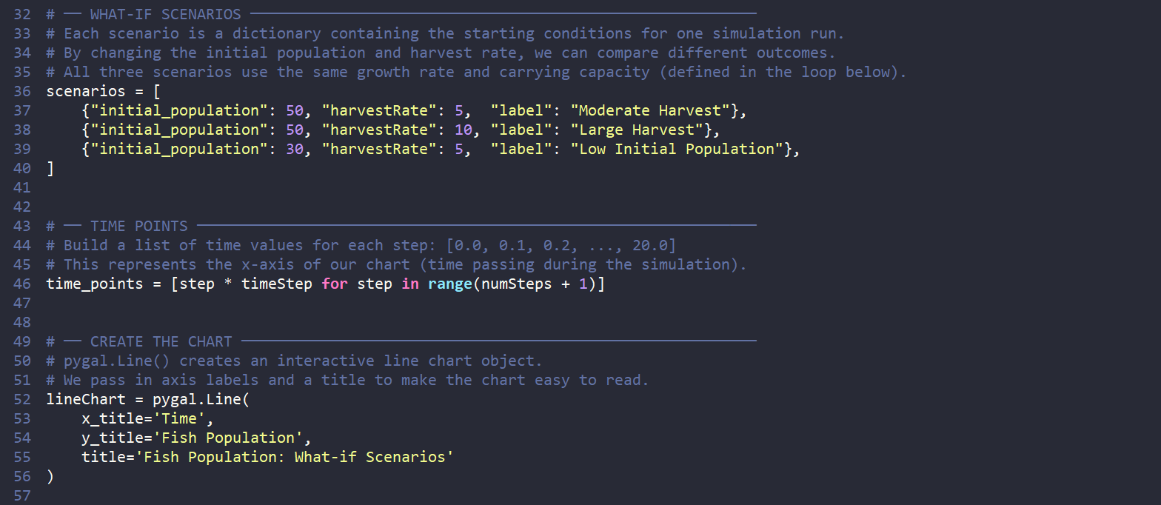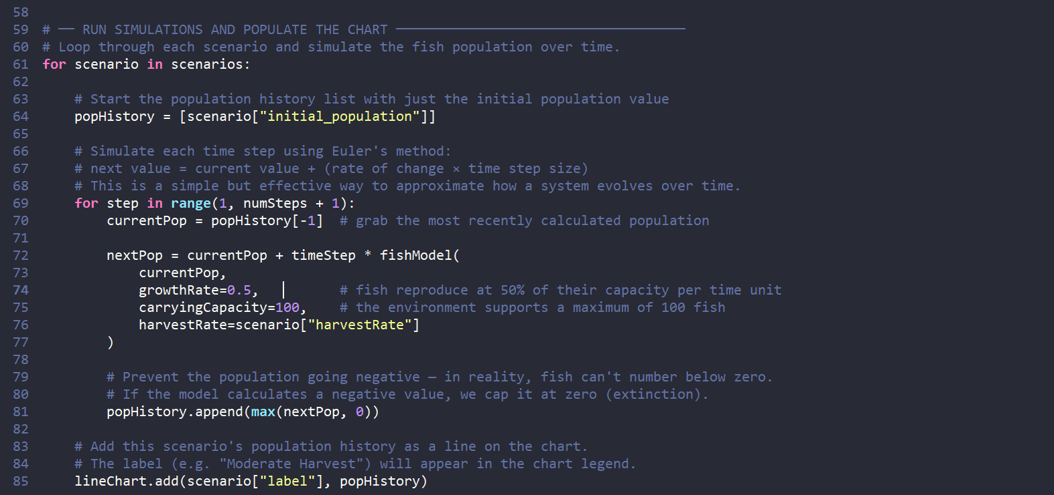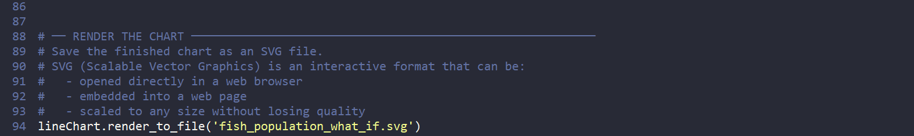

Check Your Understanding
Q1 — Breaking Down the Formula
- In the formula, what does the term (1 - population / carryingCapacity) equal when the population is at the carrying capacity? What does this mean for growth?

Your answer:

- What happens to the population if the harvest rate is larger than the growth term? Can you explain this in your own words?

Your answer:

Q2 — Comparing Scenarios
Run the code with all three scenarios. Use the interactive chart to help you answer:

Scenario | Does the population stabilise? | Approximate final population | Sustainable? (Y/N)
Moderate Harvest (5)
Large Harvest (10)
Low Initial Pop (5)

Q3 — The Tipping Point
Try increasing the harvestRate in the Large Harvest scenario step by step (e.g. 11, 12, 13...). At what harvest rate does the population collapse to zero? Record your findings:

Tipping point harvest rate and your observations:

Discussion
Consider this question as a class:

"Our model assumes harvesting is constant every single day. In reality, how might fishermen adjust their catch based on what they observe? How could you model that?"

Extension Tasks
- What if the carrying capacity changed over time — for example, due to pollution slowly shrinking the habitat? Modify the code to reduce carryingCapacity by 1 each step.
- Add a fourth scenario: a fishing ban (harvestRate = 0) that starts after the population drops below 20. Hint: you will need an if statement inside your loop.
- Compare your fish model chart to your human population chart from Lesson 1. Write two sentences explaining the key difference in how the two populations behave.

Lesson 3: Forestry Conservation — Fire & Logging
Learning Objectives
By the end of this lesson you will be able to: write a multi-variable function that combines several inputs into a single output score; choose the most appropriate Pygal chart type for different kinds of data; use a model to evaluate the impact of conservation decisions.

Background: Two Threats to Forests
Forests face many threats, but two of the most serious are wildfires and illegal logging. In this lesson you will build two separate models — one for each threat — and visualise them using different chart types.

🔥 Fire Risk Model  Uses: temperature, soil moisture, wind speed, humidity. Calculates a risk score from 0 to 100. Visualised as a LINE CHART because risk changes continuously over time. | 🪓 Illegal Logging Model  Uses: initial forest cover, logging rate, conservation factor. Tracks forest area lost each month. Visualised as a BAR CHART because losses are measured in discrete time periods.

Part A: Fire Risk Model
Understanding the Parameters

Parameter | Effect on fire risk | Range
temperature | Higher = more risk | Degrees Celsius
soil_moisture | Higher = LESS risk (inverted) | 0% (dry) to 100% (saturated)
wind_speed | Higher = more risk | km/h
humidity | Higher = LESS risk (inverted) | 0% (dry) to 100% (humid)
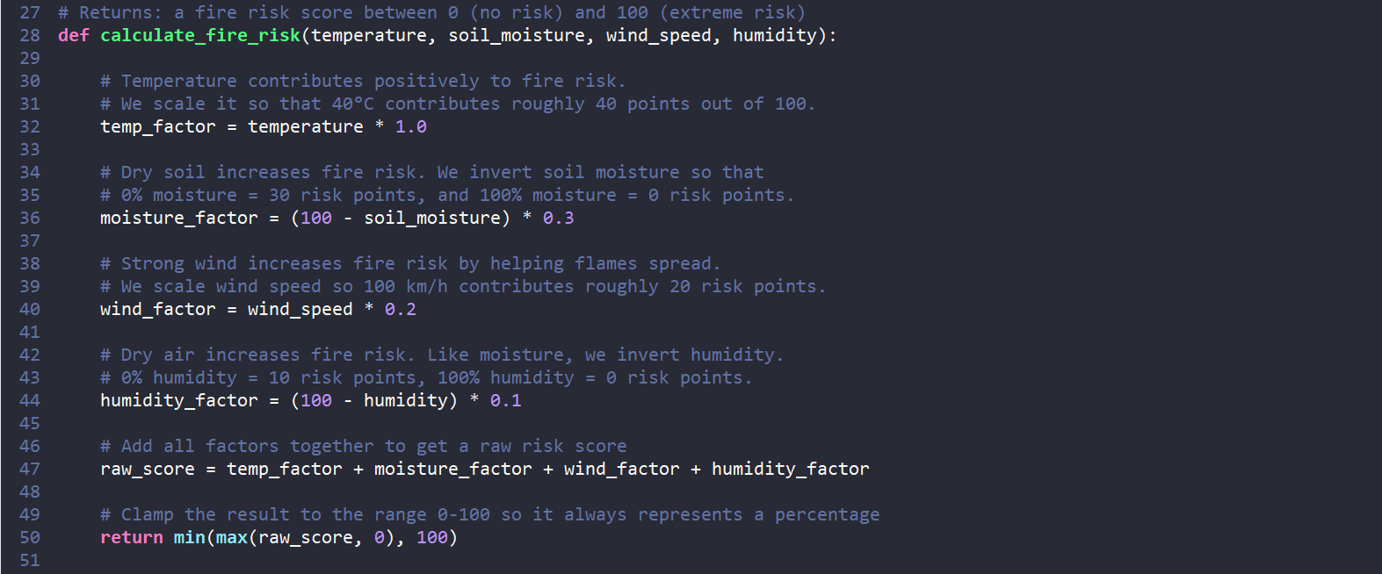
Q1 — Manual Calculation
Before running the code, calculate the fire risk score by hand for these conditions. Show your working.

Input | Value | Factor calculation | Score
temperature | 30°C | 30 x 1.0
soil_moisture | 20% | (100 - 20) x 0.3
wind_speed | 50 km/h | 50 x 0.2
humidity | 15% | (100 - 15) x 0.1
Total raw score
Clamped score (0–100)

Q2 — Chart Analysis
Run the fire risk simulation. Study the line chart and answer these questions:

- At approximately which day does the Heatwave scenario cross the score of 80 (extreme risk)?

Day number and how you estimated it:

- Why does the Moderate Conditions line still increase over time even though it starts safely?

Your explanation:

Part B: Illegal Logging Model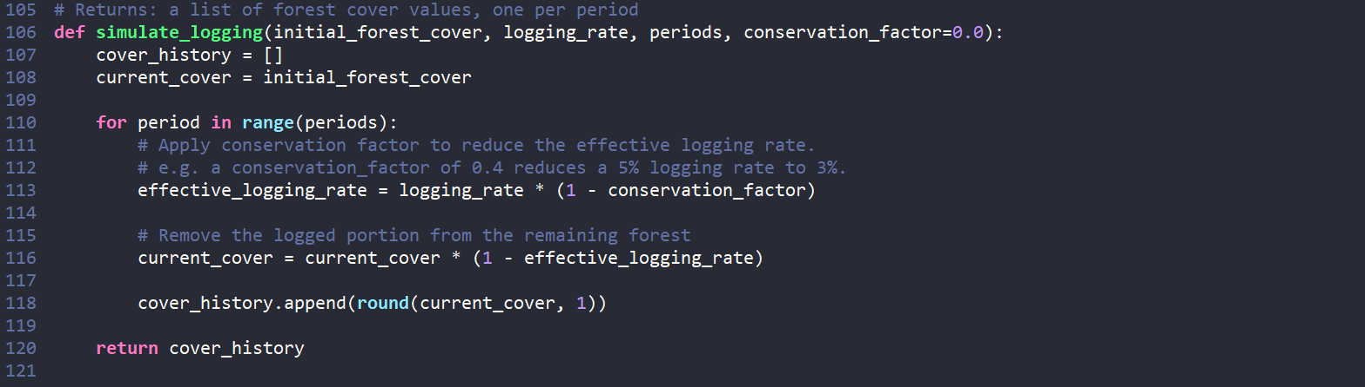
Q3 — Conservation Impact
Run the logging simulation with both scenarios. Complete the table:

 | No Conservation | Active Conservation (60%)
Forest cover after 12 months (hectares)
Forest cover after 30 months (hectares)
Hectares saved by conservation after 30 months |  | N/A

Q4 — Why a Bar Chart?
Explain in your own words why a bar chart is better than a line chart for the logging data:

Part C: Your Own Scenario
Design your own what-if scenario for EITHER the fire or logging model. Fill in the boxes below, then modify the code and run it.

Model chosen (fire / logging):
Scenario name / label:
Parameter values chosen:
What situation does this represent?
Predicted result:
Actual result after running:

Unit Review: Connecting the Three Models

The Big Picture
Across these three lessons you have used Python and Pygal to model three very different real-world systems. Despite their differences, all three programs share the same core structure — which is one of the most powerful ideas in computing.

 | Human Population | Fish Population | Forestry
Growth type | Exponential (uncapped) | Logistic (capped) | Exponential loss
Key limiting factor | None in this model | Carrying capacity | Logging rate
Human impact modelled | Growth rate choice | Harvest rate | Conservation factor
Chart type used | Line | Line | Line + Bar
Main Python concept | Loops + lists | Functions + Euler method | Multi-variable functions

Final Reflection Questions
- All three models simplify reality. Give one assumption each model makes that might not hold true in the real world.

Human population model assumption:

Fish population model assumption:

Forestry model assumption:

- A classmate says: "These are just made-up numbers — the models aren't useful." How would you respond?

Your response:

- Which of the three models do you think is closest to how scientists actually model these systems in real life? Explain your reasoning.

Your answer:

Extension: Combining the Models
Challenge Task
Can you link the models together? For example: if the forest cover drops below 5,000 hectares (due to logging), increase the fire risk base temperature by 2 degrees (less tree cover = hotter, drier conditions). This kind of linked modelling — where one system affects another — is called systems modelling and is used by environmental scientists worldwide.

Python & Pygal LCCS - The Bish R.Conboy

